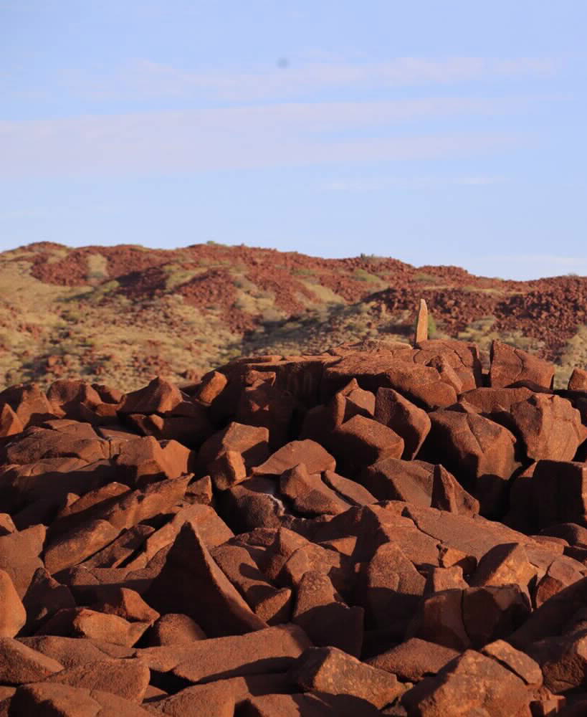  the flying foam massacre  Comprehensive Summary of Flying Foam Massacre articles by Tom Gara | ABSTRACT  Historian Tom Gara has published notes on the Flying Foam Massacre of 1868, including the names of some individuals involved. This summary combines three documents by Gara surrounding the events.

Advice
Aboriginal and Torres Strait Islander readers are advised that this document contains the names of people who have died.
Readers are informed that the following information is confronting.

Acknowledgements
We respect and acknowledge the Whadjuk Noongar people as the traditional owners of the land on which the office of Robin Chapple MLC is located.
The traditional groups of Murujuga and the North-West regions of Roebourne and Cossack are the Ngarluma and Yaburara peoples.
Tom Gara makes the following acknowledgements in his 1993 article ‘Orphan Country’;
During the course of my fieldwork, I spoke to many Aboriginal people. My principal informants were James Solomon, Roger Solomon, David Daniel, David Connors, Gordon Lockyer, Algie Patterson and Yilbie Warrie. I also spoke to many others including Sheila and Robert Boona, Mibbin Lowe, Milton Churnside, George Togo, Tim Kerr, Clare Cooper, Georgina Connors, Kenny Jerrold, Karie Monadie, Calvin Saunders, Esther Solomon, Tootsie Daniel, Colin, Susan and Janis Cosmos, Trevor Solomon, Dora Solomon, Nita Fishhook, Doreen Jane, George Sheckler, Ross and Judith Walker, David and Gladys Walker, Frank Smith and Ernie Smith. Information was also obtained from various non-Aboriginal people including Ben Sharpe, Bob Hart, Carl von Brandenstein, Jan Turner, Nic Green, Pat Vinnicombe and Jenny Gibson.

Tom Gara Primary References
Three reports have been combined in this document for the purpose of summary and conciseness. These reports are:
Gara, T. (1983). The Flying Foam Massacre: An Incident on the North-West Frontier, Western Australia. Unpublished report to Archaeology at ANZAAS
Gara, T. (1993). ‘Orphan Country No More’: Aboriginal Associations with the Burrup Peninsula. Unpublished report to the Ngurin Resource Centre.
Gara, T. (2017). Notes on the alleged murderers of Police Constable Griffis and others at Nickol Bay in February 1868. Unpublished report.

Table of Contents
The Yaburara History and Country 3
Contact and Settlement 5
Map 6
The Flying Foam Massacre 7
Official Records 7
Timeline of Official Records 8
Unofficial Accounts 10
Accounts from Aboriginal People 11
Comments 11
Named Persons involved 12
Peter 12
Police Constable Griffis 12
Bream 12
Jermyn 12
Coolyerberri 12
Woolgulgarry (OR Woolgolgarry) 12
Poodegin 13
Pulthergerri (OR Pooldalgarry, or Pulthalgarry, or Pulthalgerri) 13
Chilwell 13
Parrakarrapoogoo 13
Mulligough (OR Mullagaugh) 13
Eurunbiddy 13
Cooracoora 14
Bowera 14
Warrara 14
Nemeri 14
Euculgurri (OR Euculgurria) 14
Minnulgajebba (OR Minulgajebba) 14
Works Cited 15

The Yaburara History and Country
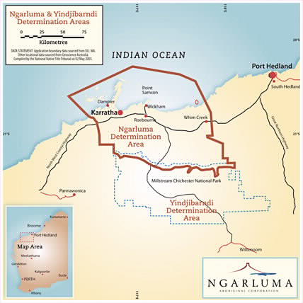
Aboriginal people have lived in the Pilbara for tens of thousands of years. The Yaburara are the traditional owners of Murujuga (the Burrup Peninsula and the islands of the Dampier Archipelago), though they are assumed to have been wiped out in the genocidal Flying Foam Massacre.
Figure 1. Ngarluma and Yindjibarndi Determination Areas. Reprinted from Ngarluma Aboriginal Corporation, N.D. Retrieved from http://www.ngarluma.com.au/
Gara comments that “it is now difficult to ascertain whether the Yapurarra [sic.] were a small tribe [sic.] in their own right or a subgroup of the Ngarluma tribe, who occupied the coastal plains between Maitland and Sherlock Rivers” (Gara, 1993). The Ngarluma people are identified the traditional owners of the mainland of the North-western Pilbara, and as of May 2005 were granted Native Title over a significant portion of the Pilbara.
Gara had a conversation recorded between Aboriginal elders at King Bay on the 16th of July – year unspecified – regarding the boundaries of Yaburara country:
Tom Gara: That whale thalu was in Yapurarra country?
Gordon Lockyer: Proper Yapurarra, right in the middle of it.
James Solomon: Yeah.
TG: And the hills near Karratha?
GL: Yeah, and Mount Leopold.
David Connors: Mount Leopold, Aboriginal name they call it Ngarrari.
(Gara, 1993).
Yaburara country extended almost as far east as the Nickol River, and included Murujuga (the Burrup Peninsula) and the northern islands of the Dampier Archipelago. Some of the western islands may have been shared between Yaburara and Martuthunira peoples. Whether the Yantare or Maitland River was the boundary to Yaburara country was undecided, but it was generally agreed that Yaburara country includes the hills around Karratha and the adjoining coastline of Nickol Bay (Gara, 1993).
Gara has also mentioned rocky hills in the coastal plain south-west of the Maitland River mouth;
The three hills are in Martuthunira country but their relative positions represent or "stand for" the three tribes; the western-most hill is the Martuthunira, the central hill stood for the Yapurarra while the eastern-most hill stood for the Ngarluma. (Gara, 1993)
Different Aboriginal peoples had different ideas of who the Yaburara country were;
During my conversations with Aboriginal elders I got the impression that whereas Ngarluma and Martuthunira people define the Yapurarra as those people living on the peninsula and islands, some Indjibarndi and other inland people use the term Yapurarra as a more general term for all the "sea-side" Ngarluma, the local groups who lived along the coast between the Maitland and Sherlock Rivers. (Gara, 1993).
The Yaburara people were resourceful, being noted for their mobility and “close association with the sea”:
The Yapurarra visited the outer islands of the archipelago on simple swimming logs, probably made from the light buoyant wood of the kurrajong tree (Gregory 1884: 56), or on a more complex type of watercraft composed of several mangrove logs lashed together (King 1827, Vol. I: 43-4). … Fishing nets up to nine metres in length, woven from spinifex fibre, were used on the beaches or in tidal creeks. The men fished with nets and spears from the shore or paddled out on their watercraft to spear dugongs and turtles. The women gathered shellfish and crustaceans from the beaches and mangroves. (Gara, 1993).
The Yaburara language has all but disappeared, aside from “70 or so words that were collected by Walcott at Hearson Cove in 1861” (Gara, 1993). Unfortunately, Yaburara language is no longer spoken. “The last speaker of Yapurarra seems to have been a man named Charlie Aleck, whose Aboriginal name was Thugari” (Gara, 1993). Roger Solomon, said:
Those Yapurarra people were no different to us. Only the language; the dialect was different - Martuthunira and Ngarluma mixed. They were West Ngarluma people but they were called the Yapurarra because they lived in that direction: sea-side. (Solomon, cited in Gara, 1993).
Estimates for the Yaburara population are around 500 and 600 people at the time of European contact.

Contact and Settlement
The Dampier Archipelago is named after William Dampier, who sighted the islands in August 1699 from the Roebuck (Gara, 1993). Philip King, commanding the Mermaid, charted the islands of the archipelago and the nearby coast of Nickol Bay in February of 1818, and he named Intercourse Island after the “friendly intercourse” that was had between Aboriginal people and himself (Gara, 1993). American whaling vessels hunting the humpback whales visited the Archipelago in the 1840s and 1850s.
Cossack and Roebourne were settled in 1863 and 1865, respectively. Reports from R. J. Sholl from May 16, 1866, stated:
“the natives continue quiet and peacable [sic]. In no part of this colony… have the early settlers been so secure from plunder or attack.” (The Inquirer, 1866, p5, cited in Gara, 1983).
The first settlement, in Cossack, was located near the mouth of the Harding River.
A drought from 1864 to 1866 caused significant adversity for Aboriginal people and settlers. In 1866 a smallpox epidemic caused many deaths in Aboriginal people, though the number of Aboriginal people who died is unknown.
“Rich beds of pearlshell [sic] were discovered in Nickol Bay in 1865”, which lead to the ending of peaceful relations between Aboriginal people and settlers. Aboriginal people were “employed” as divers in exchange for tobacco, flour, and other goods:
The pearlers, most likely, had little regard for the local Aborigines when they dispossessed them of the vital water supplies there. The Yapurarra apparently responded to these intrusions by stealing food and other goods from the pearlers' camps and from the boats offshore. (Gara, 1993).
Gara also notes that the “employment” was forceful:
Aboriginal men were abducted to work as divers on the boats; Aboriginal women were also abducted to work as divers and as sexual partners for the white pearlers. … In many cases, if inducements failed, the Aborigines were simply kidnapped, chained together and marched to the boats on the coast. From there they may have been transported to pearling grounds hundreds of kilometres from their homes and abandoned there at the end of the season (Gribble 1905: 30). Aboard the boats, the murder, mistreatment and rape of Aborigines was [sic.] commonplace. In 1870 an outbreak of smallpox caused many deaths among the Aborigines employed on the boats. (Gara, 1993).
Some Aboriginal women were abducted and kept as slaves on islands off the archipelago, and “sold off to the masters of the pearling boats” (Gara, 1993).
Around 20 years after the settlement of Roebourne, the Flying Foam Massacre occurred. Conflicting reports about the number of Aboriginal people killed has been a topic of contention, particularly in Gara’s work. Gara notes that the Yaburara “were effectively destroyed as a social unit in frontier conflict in the late 1860s” (Gara, 1993):
The few survivors were scattered along distant coasts by the pearling boats, or sought refuge on the pastoral stations inland. Early ethnographic sources … record a great deal of useful information on the material culture, subsistence techniques, customs and beliefs of the Ngarlima tribe. However, little is known specifically on the Yapurarra [sic.]. (Gara, 1993).
“There may be people of Yapurarra descent scattered throughout the north-west of the state who know little if anything of their heritage” states Gara (1993).

Map
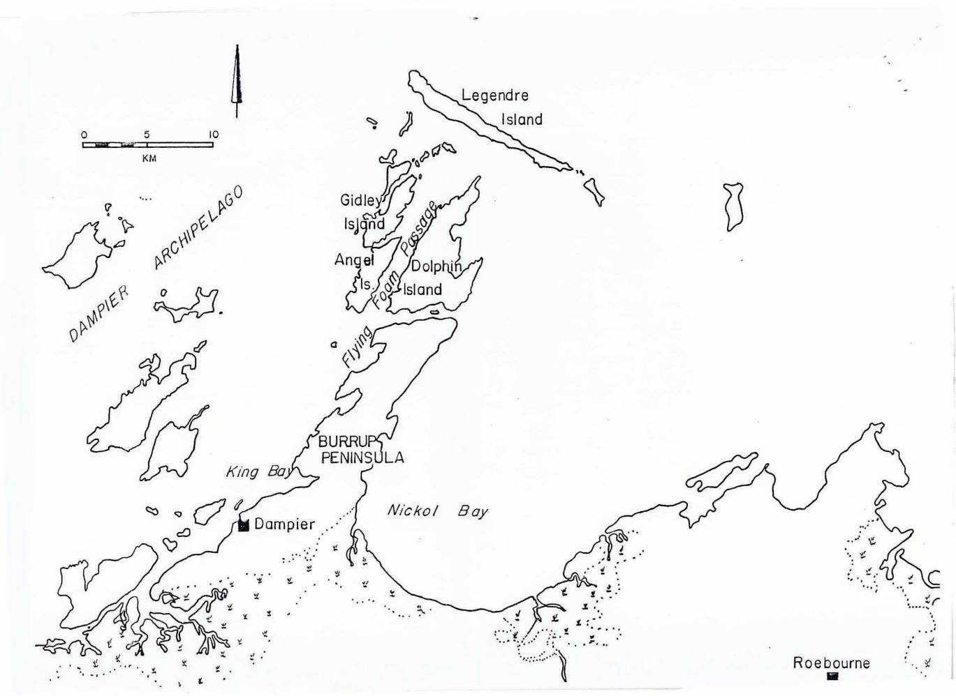
The Flying Foam Massacre occurred in the north-west coastal region of the Pilbara, around Nickol Bay, the Flying Foam Passage, and Roebourne depicted below.
Figure 1. Map of the upper coastal Pilbara region of North-West Western Australia, where the Flying Foam Massacre occurred. (Gara, 1983)

The Flying Foam Massacre
The Flying Foam Massacre occurred in February of 1868, and was not a singular event, but a sequence of murders carried out by settlers against the Yaburara people. It occurred around King Bay and the Flying Foam Passage over the course of three or four days.

Official Records
In February 1868, Aboriginal local Peter and Police Constable Griffis – of whom Peter was a ‘native assistant’ – left Roebourne to arrest an Aboriginal man known as Coolyerberri, who was accused of stealing flour from a pearling vessel at Nickol Bay. Coolyerberri, according to Gara’s 1993 report, was not the only Aboriginal person to steal flour from the pearling boat. Coolyerberri was arrested by Peter and Griffis on the 6th of February, and chained by the neck to a tree (Gara, 1983).
Other Aboriginal locals freed Coolyerberri at night, and speared to death Griffis, Peter, and a pearler named Bream (the latter of whom happened to be camping nearby) (Gara, 1983; 2017). Bream’s partner Jermyn was also presumed killed, but his body was never found. During an investigation by the Government Resident for Roebourne at the time, R. J. Sholl, it was estimated that around 100 Aboriginal people had been present for the murders.
Some of the Aboriginal locals who were unnamed in Gara’s 1983 report, attempted to prevent the others from attacking the police camp. They told Sholl what had occurred, and the names of nine principal murderers:
“Poodegin alias Charley, Woolgolgarry [sic] alias Ned, Mullagaugh, an island native, Minulgajebba, an island native, Parrakarrapoogoo, an island native, Cooracoora … and Chilwell.” Three other Aborigines were later named as being involved in the murders: “Pulthalgerri alias Big Monkey, Euculgurria alias Jimmy, a lad who took spears with him, Warrara, an island native.” (Gara, 1993).
They informed Sholl that the suspects had fled to the islands around Flying Foam Passage.
When Sholl returned to Roebourne, he assembled two parties of “special constables” to find the alleged murderers (Gara, 1983; 1993). Alex McRae was in charge of a party of ten who headed west to the peninsula (arriving at Hearson Cove on the 16th of February). John Withnell was in charge of the other party (also of ten), and sailed around the Flying Foam Passage.
On the 17th of February, McRae surrounded the suspects.
McRae claimed that he found items taken from the dead policeman in the camp. The boat party, led by J. Withnell, arrived at the scene at about the same time and, on the following day, transported McRae's men to Dolphin Island.
Over the next few days, the two groups of special constables apparently roamed around the islands of Flying Foam Passage, firing upon any Aborigines they saw… McRae's men shot and killed one man they caught crossing the passage on a log and fired at some others they saw on one of the islands. On that occasion, "several were shot or wounded", according to McRae. (Gara, 1993).
McRae writes an official report on the events of his party’s investigation and pursuit on the 25th of February. He describes what happens on the 17th:
“were [sic] camped on a clear sandy beach a few yards from the mangroves but before we could get within reach of them they saw us and made for the mangroves and the hills at the back of the camp … they would not stop to be arrested so we had no alternative but to fire upon them, [w]hen one of the murderers, ‘Chilwell’ was shot dead and several others wounded. I regretted much to have to take this step with these misguided creatures … but their escape without a lesson would only lead to further outrages.” (McRae, 1868, cited in Gara, 1983).
On the 19th of February, some Aboriginal people were seen crossing the Flying Foam passage on logs. On the 20th of February, “Withnell had what he described only as a ‘sharp skirmish’ with Aborigines on either Angel or Girley Island but he provided no account of the casualties in his official report” (Gara, 1983).
McRae and Withnell returned to Roebourne on the 25th of February.
Sholl writes to the Colonial Secretary on the events:
“I have tendered to Messrs. Withnell and McRae and the gentlemen associated with them my [sic] thanks for the services they have rendered and I have no hesitation in saying that by their action, loss of life amongst the isolated whites has been prevented, the well-disposed natives confirmed in their amity towards us, the wavering made steadfast, the guilty terrified and the old feeling of security revived amongst the whole white population.” (Sholl, 1868, cited in Gara, 1983).
McRae and Withnell’s reports indicate “only a small number of Aborigines, perhaps five or ten, had been killed” (Gara, 1983). Two individuals captured on Dolphin Island were able to escape, as Withnell did not have handcuffs or chains. It is certain from official records that some Aboriginal people died on the islands around the Flying Foam Passage. In July, Coolyerberri was shot by Billy, the native assistant of Police Constable Francis (Gara, 2017).

Timeline of Official Records

6 February 1868
Police Constable Griffis arrests Coolyerberri. Coolyerberri is chained to a tree.

7 February 1868
Police Constable Griffis, Peter, and Bream are speared to death. Jermyn is presumed dead.

15/17 February 1868
Chilwell is shot dead. It is stated as the 15th of February in Gara’s 2017 article and the 17th in the 1983 article.

17 February 1868
Alex McRae surrounds an Aboriginal camp, (assumed to be the south shore of King Bay). Withnell’s boat party arrives “shortly after” this incident (Gara, 1983).

18 February 1868
Sholl writes a report on the events and claims of [Name].

19 February 1868
Some Aboriginal people were seen crossing the Flying Foam Passage on logs.

20 February 1868
“Withnell had what he described only as a ‘sharp skirmish’ with Aborigines on either Angel or Gidley Island but he provided no account of the casualties in his official report” (Gara, 1983).

25 February 1868
Withnell and McRae’s parties return to Roebourne.

March 1868
Parrakarrapoogoo, Woolgulgarry, and an innocent Aboriginal man are shot dead while trying to escape by Police Constable Francisco or one of his ‘native assistants’ (Gara, 1983; 2017). In Gara’s 1983 article, it is suspected that the location of their death was the Maitland River, but in the 2017 article, “Hampton Harbour” is listed.

May 1868
At least eight more Aboriginal men, Poodegin, Pulthergerri, Mulligough, Cooracoora, Eurunbiddy, Warrara, Nemeri, and Bowera were arrested on Legendre Island. Mulligough, Cooracoora, and Eurunbiddy were sentenced to 12 years’ imprisonment on Rottnest Island after being tried in the Perth Supreme Court.
It was reported that Poodegin was shot dead on Legendre Island in May, but he was only wounded in the thigh (Gara, 2017).
Warrara, Nemeri, and Bowera were tried in the Roebourne Court. Warrara was sentenced to three years’ gaol on Rottnest Island. Nemeri was acquitted. Bowera was sentenced to three years’ imprisonment with hard labour in Rottnest Prison.

July 1868
Coolyerberri was shot dead by Police Constable Francisco’s ‘native assistant’ Billy near the mouth of the Maitland River.

February 1869
Poodegin and Pulthergerri return to Roebourne. “Sholl was to take no action against these two men” (Gara, 1983). Sholl wrote on the 27th of February:
“As the trial of these men would involve much expense, for the witnesses employed in the previous trial would have to be forwarded to Perth, as well as an interpreter (if one can be obtained), I have not arrested these men. As they do not anticipate evil I can take them at any time should His Excellency the Governor authorize their arrest. Personally I am in favour of amnesty, for the natives have received a severe lesson and much blood has been spilt” (Sholl, 1869, cited in Gara, 2017).

13 August 1870
Bowera dies in prison.

27 January 1874
Cooracoora dies in prison.

30 August 1877
Mulligough and Eurunbiddy are released from prison on Rottnest Island.

Unofficial Accounts
Though official records claim that around 10 or so Aboriginal locals were murdered, speculation that the massacre involved the deaths of a possible 60 Aboriginal locals rose outside of police reporting. “As one of his sons was a member of McRae's party, it can be presumed that Sholl was aware that Withnell and McRae understated the number of Aborigines killed and that he gave his overt or covert support to the actions of the special constables” (Gara, 1983).
“Allegations that the special constables had participated in a massacre of Aborigines were not made public until 1885” (Gara, 1983). David Early (one of the settlers in Roebourne) wrote to Reverend J. B. Gribble about the massacre:
“it is very well-known by all old hands around Nickol Bay and the Flying Foam Passage that in one day there were quite sixty natives, men, women and children shot dead. The natives have shown me the skulls of 15 who were shot dead. Three of the skulls were those of children, and two of these small skulls had bullet holes in them” (Gribble, 1905, cited in Gara, 1993).
In 1886, Gribble sued the editor of the Western Australian for libel. Soon, Gribble’s allegations were forgotten.
In a letter to the Colonial Secretary from William Taylor (a settler at Roebourne), 1869, the harsh treatment of Aboriginal people in the region at the hands of the police was revealed. Taylor wrote:
“the former policeman Griffths [sic] met his death about a year ago in consequence of the excesses which he committed on the blacks – I believe that the immediate cause was the carrying off of 2 [sic] women to Roebourne … Mr Sholl then mustered what whites he could and murdered blacks, some members of this party committing the most cowardly and diabolical acts both on innocent women and children.” (Taylor, 1869, cited in Gara, 1983).
John Watson, a pearler, did not participate in the events of 1868, but was involved in the arrests of Aboriginal people on Legendre Island a few months after. His account was written more than 60 years after the events:
“At daylight next morning the land party [came] upon a number of natives in camp … They were shot down while others took to the water only to be finished off by the boat party. I leave it to the imagination of my readers to picture the public indignation that would be aroused today by such slaughter, perpetrated as it was with the colourable approval of the responsible Government official of the district” (Watson, 1993, cited in Gara, 1983).
If Watson’s account is accurate, the site of the slaughter would be the Aboriginal Camp at King Bay, attacked by McRae on the 17th of February.

Accounts from Aboriginal People
In Roebourne, a Ngarluma man named Coppin Dale was interviewed by Nic Green from the Western Australian Museum:
“Lot of Yaburara people there, long time ago. This policeman took a young girl into the bush, with a rifle. The old fella [the girl’s husband] he got a spear in his hand, he put the spear right through the policeman’s chest. The other police all got their guns, went out there, got all the Yaburara people up, got them all together, shot them down. Must be 30, 40 people killed.” (N. Green, personal communication, cited in Gara, 1983).
This is evidence that the death toll was highly understated in official reports. Other, more recent information has also been provided:
Coppin Dale has since told Jan Turner (1990: 43) a detailed account of the shootings that appears to correspond closely with what is known of the movements of the special constables. He did not wish this information to be made public, however. Jan Turner also heard stories about the massacre from other Roebourne elders, since deceased, in the early 1980s. (Gara, 1993).
David Connors, an Aboriginal man from Warambie station commented on the Massacre:
They all got shot. King Mullagong [footnote reads: “Mullagong was a Ngarluma man, described by the early settlers at Cossack and Roebourne as the “chief” of the local Aboriginal people (Gara, 1984: 8-9).”], that fella that showed the Withnell brothers Roebourne, he didn't like those people down there, he had something against them. He got the coppers there to go and shoot them. One of the coppers got speared too! … they wiped the whole lot out, women and children too. Only one young fella left, he fell beside the old fellas and the blood all covered him and after they shot them all, they kicked the young fella in the ribs … The young fella he was alive for quite a while - he killed a lot of policemen, police boys and all. He used to wait for them and he got hold of one of their rifles and learned about it. He ended up shooting them before they got there because they had to come across in a dinghy - they reckon he was really bloody deadly. (Gara, 1993).
Gara finds that estimates of a death toll of the Massacre around 150 people to be “clearly exaggerated” (Gara, 1993).

Comments
Taylor’s belief that Griffis was killed in relation to the abduction of Aboriginal women is also supported. Gara offers the following comments:
“It seems unlikely that Peter, Jermyn and Bream were merely innocent bystanders. Whether Sholl was aware of the true circumstances of Griffs’ death at the time is a matter of conjecture. Taylor’s letter suggests that the circumstances of Griffs' death were common knowledge in Roebourne at least by January 1869.” (Gara, 1983).
Gara also speculates that Withnell did not intend to take any suspects prisoner due to his lack of handcuffs and chains. “Although the alleged murderers were supposed to have gone ·to the islands around Flying Foam Passage, McRae's party, and possibly Withnell's too, attacked an Aboriginal camp at King Bay” (Gara, 1983).
One observation, from Henry Reynolds’ book The Other Side of the Frontier which Gara has cited states that:
Pioneer communities appeared to be unable to cope with the psychological tensions produced by even small amounts of inter-racial violence. The punitive expedition - official and unofficial -was the almost universal riposte. The objective was simple: the use of overwhelming force to crush resistance once and for all and drown in blood the Aboriginal determination to take an eye for an eye and a tooth for a tooth. (Reynolds 1981: 63, cited in Gara, 1993).

Named Persons involved
Nicknames are Gara’s inclusion.

Peter
Murdered on the 8th of February, 1868.

Police Constable Griffis
Murdered on the 8th February, 1868.

Bream
Murdered on the 8th February, 1868.

Jermyn
Suspected to have been murdered on the 8th February, 1868. Knowledge of his death is denied by Aboriginal locals. It appears that Jermyn died along the way from Nickol Bay to Cossack (previously known as Tien Tsin) before the murders occurred.

Coolyerberri

(AKA “Entire”, or “MacIntyre”)
Arrested on 6th February 1868 for stealing flour. Suspect in the murders of Peter, Griffis, and Bream. Coolyerberri allegedly cooperated with Poodegin and Woolgulgarry. Shot dead in July 1868, by Police Constable Francisco’s ‘native assistant’ Billy near the mouth of the Maitland River.

Woolgulgarry (OR Woolgolgarry)

(AKA “Ned”)
Shot and killed while attempting to escape by Police Constable Francisco’s ‘native assistant’ “Monkey”, possibly near Hampton Harbour, in 1868.

Poodegin

(AKA “Charlie”)
Suspect in the murders of Peter Griffis, and Bream. Wounded in the thigh by Police Constable Francisco in May 1868. Returned to Roebourne in 1869 and did not face prosecution.

Pulthergerri (OR Pooldalgarry, or Pulthalgarry, or Pulthalgerri)

(AKA “Big Monkey”)
In February 1869 Sholl reported that Poodegin and Pulthergerri had returned to Roebourne. Pulthergerri did not face prosecution.

Chilwell
Suspect in the murders of Peter, Griffis and Bream. In Gara’s 1983 article, it was stated that Chilwell was shot on the 17th of February, 1868. In the 2017 article, it is stated that Chilwell was shot dead by members of McRae’s party at King Bay on the 15th of February (Gara, 2017).

Parrakarrapoogoo

(An ‘island native’)
Shot and killed while attempting to escape by either Police Constable Francisco, or one of his ‘native assistants’, “Monkey” or “Woobat”, near Hampton Harbour in March 1868. It is implied in Gara’s 1983 article that Parrakarrapoogoo was a suspect, and not innocent.

Mulligough (OR Mullagaugh)

(An ‘island native’)
Arrested by Withnell’s party on the 17th of February 1868, along with another man (unnamed) ‘implicated’ in the murders. The two men escaped.
Mulligough was arrested again on Legendre Island in May 1868, along with Eurunbiddy and Cooracoora, and committed for trial to the Supreme Court in Perth for murder. He was found guilty and originally sentenced to death, but then later commuted to Rottnest Island for life imprisonment. He was released on the 30th August 1877.

Eurunbiddy

(AKA “Castor Oil”)
Arrested on Legendre Island in May 1868 along with Mulligough and Cooracoora, and committed for trial to the Supreme Court in Perth for murder. He was found guilty and originally sentenced to death, but then later commuted to Rottnest Island for life imprisonment. He was released on the 30th August 1877.

Cooracoora

(AKA “Weenjow”)
Arrested on Legendre Island in May 1868 along with Mulligough and Eurunbiddy, and committed for trial to the Supreme Court in Perth for murder. He was found guilty and originally sentenced to death, but then later commuted to Rottnest Island for life imprisonment. He died in prison on the 27th of January 1874.

Bowera

(AKA “Dicky”)
Bowera was convicted in the Roebourne Court in May 1868 for having stolen flour from the tent of H. Jermyn, and was sentenced to three years’ imprisonment with hard labour in Rottnest Prison. He died in prison on the 13th of August 1870.

Warrara

(An ‘island native’)
Arrested on Legendre Island in May 1868. He was sentenced in Roebourne Court to three years’ gaol on Rottnest for robbing Jermyn’s tent.

Nemeri

(An ‘island native’)
Arrested on Legendre Island in May 1868. He was acquitted in the Roebourne Court after being charged with robbing Jermyn’s tent.

Euculgurri (OR Euculgurria)

(AKA “Jimmy”)

Minnulgajebba (OR Minulgajebba)

(An ‘island native’)

Works Cited
Gara, T. (1983). The Flying Foam Massacre: An Incident on the North-West Frontier, Western Australia. Unpublished report to Archaeology at ANZAAS
Gara, T. (1993). ‘Orphan Country No More’: Aboriginal Associations with the Burrup Peninsula. Unpublished report to the Ngurin Resource Centre.
Gara, T. (2017). Notes on the alleged murderers of Police Constable Griffis and others at Nickol Bay in February 1868. Unpublished report.
N/A. (2017). “National Heritage Listed Murujuga landscape” [Photograph]. Research Impact at UWA. https://researchimpact.uwa.edu.au/research-impact-stories/murujuga-dynamics-of-the-dreaming/

Referred to as Yapurarra in Gara’s 1993 article.
Thalu refers to Kadarrabuga Thalu (Whale Thalu) – a “totemic site” for ceremonies and rituals: “associated with a different species of animal or plant or with some natural phenomenon such as rain or cooler weather. The members of the local group "owned" the ceremonies and songs associated with the thalu sites, and by performing those ceremonies they could ensure that the particular animal or plant species associated with that site continued to increase in numbers or that rain or cooler weather would come” (Gara, 1993).
Police Constable Griffis has been named differently in separate Gara articles. Griffis is referred to as “Griffs” in Gara’s 1983 article, and as “Griffis” in Gara’s 2017 article.
In Gara’s 1993 report, he states that the men “speared to death Griffis, Peter, and two white pearlers camped nearby”, implying that Jermyn was also murdered.
In Gara’s 1983 report, only one informant was implied, and remained unnamed.
In Gara’s 2017 report, Woolgolgarry was spelt Woolgulgarry.
In Gara’s 2017 report, Mullagaugh is spelt Mulligough
In Gara’s 2017 report, Minulgajebba is spelt Minnulgajebba
In Gara’s 2017 report, Pulthalgerri is spelt Pulthergerri. Multiple spellings of this name exist.
In Gara’s 2017 report, Euculgurria is spelt Euculgurri
In Gara’s 1983 article, Woolgulgarry was spelt ‘Woolgolgarry’. In the 2017 article, it was spelt as above.
In Gara’s 1983 article, it states that four men were arrested on Legendre Island in May. Only Poodegin and Pulthergerri were named, two other men remain unnamed. This information has been updated to “eight men”, as in Gara’s 2017 article, Mulligough, Cooracoora, Eurunbiddy, Warrara, Nemeri, and Bowera are named. It is unclear as to whether the unnamed two of the original “four” are named in the 2017 article. It is possible that a total of 10 men were arrested.
Pulthergerri (Gara, 2017) is likely the same person named Pulthalgarry (Gara, 1983)/Pooldalgarry (Gara, 2017).
(Gara, 1993)
Gara did not make it clear whether “Monkey” is “Big Monkey”, Pulthergerri, but this is unlikely, as Pulthergerri was arrested.
(Gara, 2017)
(Gara, 1983)
(Gara, 1993)
This information is contradictory with Gara’s 1983 article – it makes more sense for him to have been killed on the 17th of February.
(Gara, 1993)
(Gara, 1993)
(Gara, 1983)

