New fine default legislation could help lower Indigenous imprisonment rate says Greens' MP Robin Chapple
Updated 21 minutes ago
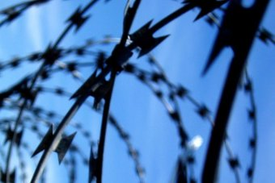PHOTO: There is hope new legislation tackling fine defaulting could potentially help lower the Aboriginal incarceration rate.(www.sxc.hu: chidsey)
RELATED STORY: WA Premier backs plan to quarantine welfare payment for fine defaulters
MAP: WA
A Kimberley-based Greens' MP says the introduction of a new method to help fine defaulters pay off their debts would keep many Indigenous Australians out of prison.
Currently people can agree to have up to 14 per cent of their income quarantined to pay off bad debts but can reverse that arrangement at any time at their discretion.
Federal Indigenous Affairs Minister Nigel Scullion is trying to convince the Western Australian Government to introduce legislation blocking people from backing out.
The Greens' Robin Chapple said the measure could potentially lower the Aboriginal incarceration rate and therefore curb the number of deaths in custody.
"The larger picture of trying to deal with the problems of fine defaulting, excessive custody of Indigenous people, can certainly be dealt with by the 14 per cent deduction," he said.
He said it could prevent situations like the August 2014 death of Ms Dhu, in police custody in the Pilbara, for unpaid fines.
"Incarceration should always be the last resort for a fine default," he said.
"If managed properly, we should never get there.
"You could make orders for community service, which would be far better than incarceration."

